Modules

# Login (/login)

## Flow

* Frontend
  + Check
    - Password Length
  + If success
    - Move to “/inbox”
* Backend:
  + Check
    - User exists
    - Password is valid for the user
  + Workflow
    - Check validation token
    - If token is expired, create new token
    - Save token in the database
  + Return if success
    - Token

## API

* Request:
  + Method: Get
  + Header: -
  + Body:
    - Identifier
    - Password
* Answer
  + Success:
    - Token

## Screenshot

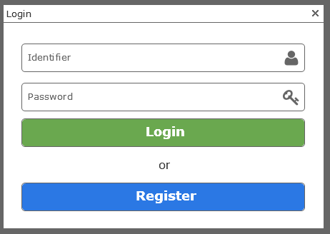

# Logout (/logout)

## Flow

* Frontend
  + Empty localStorage

# Register (/register)

## Flow

* Frontend
  + Check
    - Password (All)
  + If success
    - Move to “/inbox”
* Backend
  + Workflow
    - Create token
    - Create and save user
  + Return if success
    - Token

## API

* Request:
  + Method: Post
  + Header: -
  + Body:
    - Name
    - Surname
    - Identifier
    - email
    - Password
    - country
* Answer
  + Success:
    - Token

## Screenshot

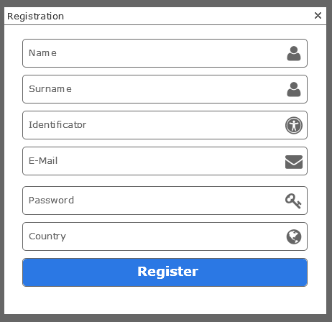

# Inbox (/inbox)

## Flow

* Frontend
  + Workflow
    - Fetch 100 first documents from backend
  + Click on
    - View: move to inbox {id}
    - Download: Download selected documents
    - Print: print selected documents
    - Send: move to “/inbox/{id}/sendto”
    - Move: move to “/inbox/{id}/move”
    - Archive: move to “/archieve”
    - Settings: move to “/inbox/categories”
* Backend
  + Workflow
    - Get list of documents for this user and category
  + Return if success
    - List of transactions + document

## Screenshot

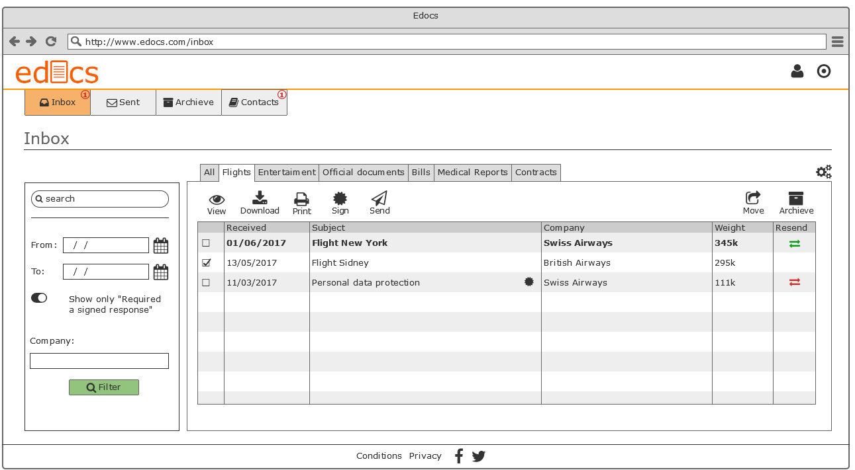

Technical

Database

* Identifier id (user):
  + Unique
* Password (user)
  + Encryption with BCrypt
  + 8 characters minimum
  + Must contain at least 1 uppercase letter and 1 number

Store

* **Transactions [ {category [{transaction}]}]**
* **User**
* **Contacts**